Kyla Marrero
December 4, 2022
RTL2122
Floor Plan
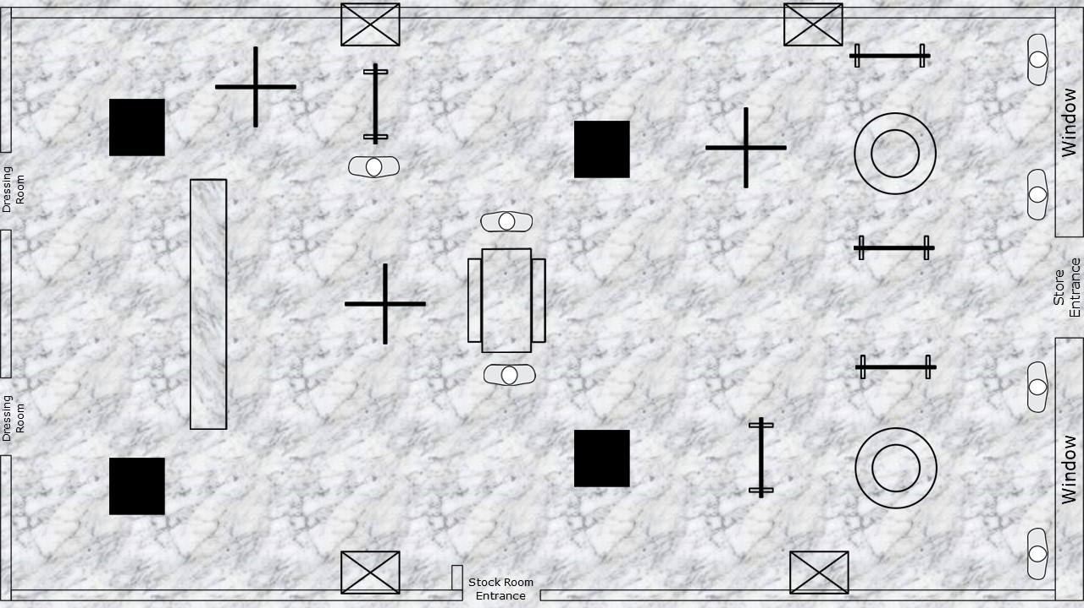
For the floor plan, I showed marble flooring throughout the store. Near the entrance of the store in both window displays, 2 mannequins display some of the merchandise from the assortment. We have the Skort, Blouse Top, and Denim Jacket on the far-right mannequin in the right window, and the Pleat Skirt, Shirt Top, and Sweater on the far-left mannequin in the right window. In the left window, we have the Clear Baby Doll Coat and 1-Shoulder Dress on the far-right mannequin. While the Slit Skirt and Peplum Top are displayed on the far left of the left window.
The Denim Jackets are displayed behind the mannequin on the T-Stand on the right of the store. In front of that, we have a table rounder where the Skorts are displayed. To complete the look shown on the mannequin on this side of the store, we have the Blouse Tops on the 4-way display. For the second mannequin look in the right window, you can find the pleated Skirts on the same table round as the Skorts. The Shirt Tops are on the 4-way, and the T-Stand towards the store entrance has the Sweaters displayed.
On the left side of the store, we have the table rounder in the middle behind the mannequins that display the Slit Skirt shown on the mannequin. A T-Stand is near the entrance parallel to the one on the right side of the store and carries the Clear Baby Doll Coat and 1-Shoulder Dress. Directly behind the table rounder is another T-Stand with the Peplum Tops for the Slit Skirt. 2 portraits of the clothing assortment are on opposite sides of the store towards the front entrance. Following behind the 4-way there is a mirrored column and another parallel to this behind the T-stand.
As you make your way toward the back of the store. There is a “Picnic” style shop table that displays the Sweatpants from the clothing assortment. On both sides of this table are 2 mannequins, each with different colors of the Sweatpants and Zip Up Hoodie. A 4-way stand is behind the table to display the Mint Green and Starfish Pink Zip-Up Hoodie. On the right side of the 4-way stand is another mannequin displaying the Trench coat and bodycon dress. Directly behind this is a T-stand with Trench Coats. On the 4-way stand towards the back of the store, we have the Bodycon Dresses in Deep Blue and Jellyfish Pink.
Once you are at the back of the store, you have the cash wrap in the middle of the store between the dressing rooms. Behind the cash wrap on both sides, are mirrored columns. More pictures are displayed on the wall of the clothing assortment next to the stock room entrance and directly parallel to that.

